**Assignment -3**

|  |  |
| --- | --- |
| Assignment Date | 22 September 2022 |
| Student Name | Arul Jeshin A |
| Student Roll Number | 111519205001 |
| Maximum Marks | 2 Marks |

**Question 1:**

Create a bucket in IBM object Storage.

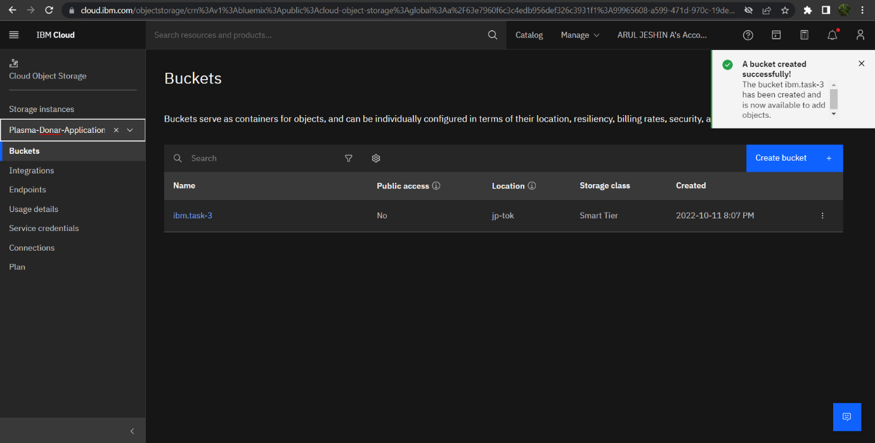

**Question 2:**

Upload any 5 images to IBM object storage and make it public. Write HTML code to display all the 5 images.

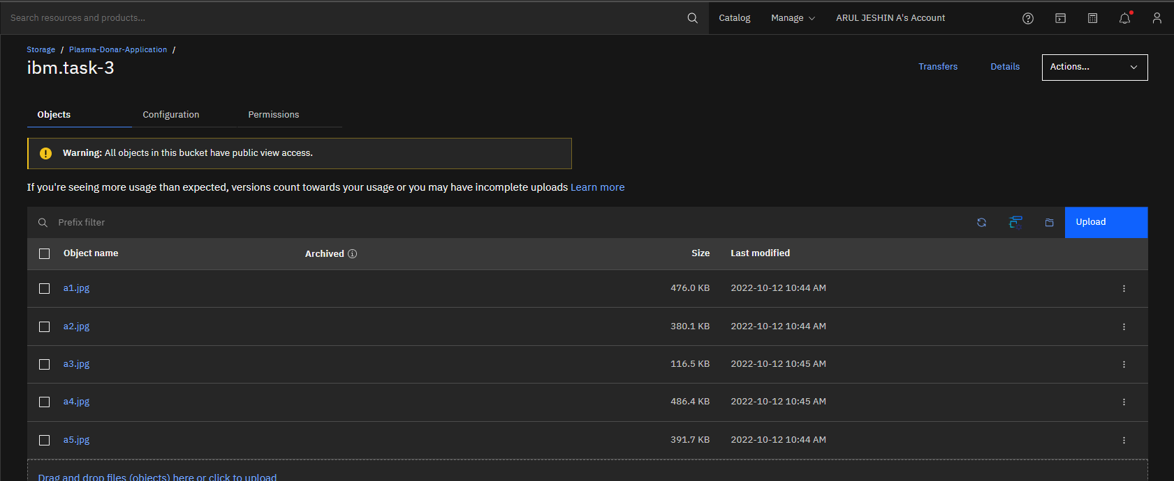

**HTML code for displaying images in cloud :-**

<!DOCTYPE html>

<html lang="en">

<head>

    <meta charset="UTF-8">

    <meta http-equiv="X-UA-Compatible" content="IE=edge">

    <meta name="viewport" content="width=device-width, initial-scale=1.0">

    <title>Document</title>

</head>

<style>

    body{

        text-align: center;

        background-color: black;

    }

    h2{

        color: goldenrod;

        font-size: 50px;

    }

    h1{

        color: white;

        text-align: center;

        font-size: 75px;

    }

    img{

        height: 230px;

        width: 430px;

    }

</style>

<body>

    <h1>NARUTO CHARACTERS</h1>

    <h2>sasuke-naruto</h2>

<img src="https://ibm.task-3.s3.jp-tok.cloud-object-storage.appdomain.cloud/a1.jpg" alt="sasuke-naruto">

<h2>sasuke-chidori</h2>

<img src="https://ibm.task-3.s3.jp-tok.cloud-object-storage.appdomain.cloud/a2.jpg" alt="sasuke-chidori">

<h2>uchiha-ghost</h2>

<img src="https://ibm.task-3.s3.jp-tok.cloud-object-storage.appdomain.cloud/a3.jpg" alt="uchiha-ghost">

<h2>hashirama-madara</h2>

<img src="https://ibm.task-3.s3.jp-tok.cloud-object-storage.appdomain.cloud/a4.jpg" alt="hashirama-madara">

<h2>itachi-sharingan</h2>

<img src="https://ibm.task-3.s3.jp-tok.cloud-object-storage.appdomain.cloud/a5.jpg" alt="itachi-sharingan">

</body>

</html>

**HTML Output for displaying images from IBM cloud storage: -**

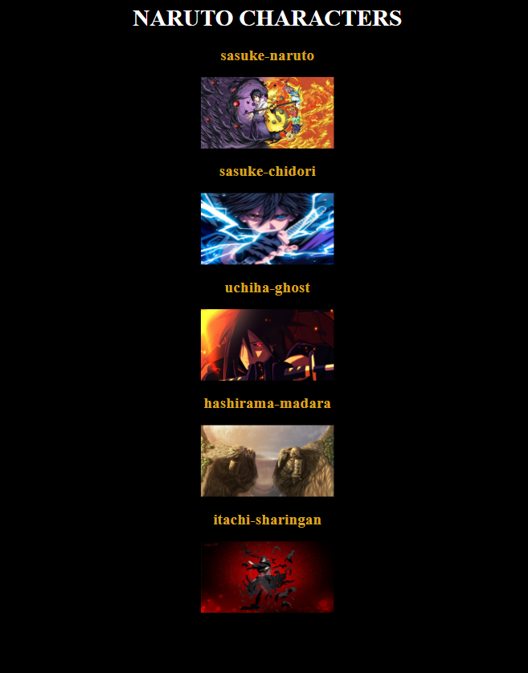

**Question 3:**

Upload a CSS page to the object storage and use the same page in your HTML code. HTML code with CSS file present in IBM cloud storage.

**Style.css code:**

body{

    background-color: black;

}

h1{

    text-align: center;

    color: orangered;

}

p{

    color: white;

    text-align: center;

}

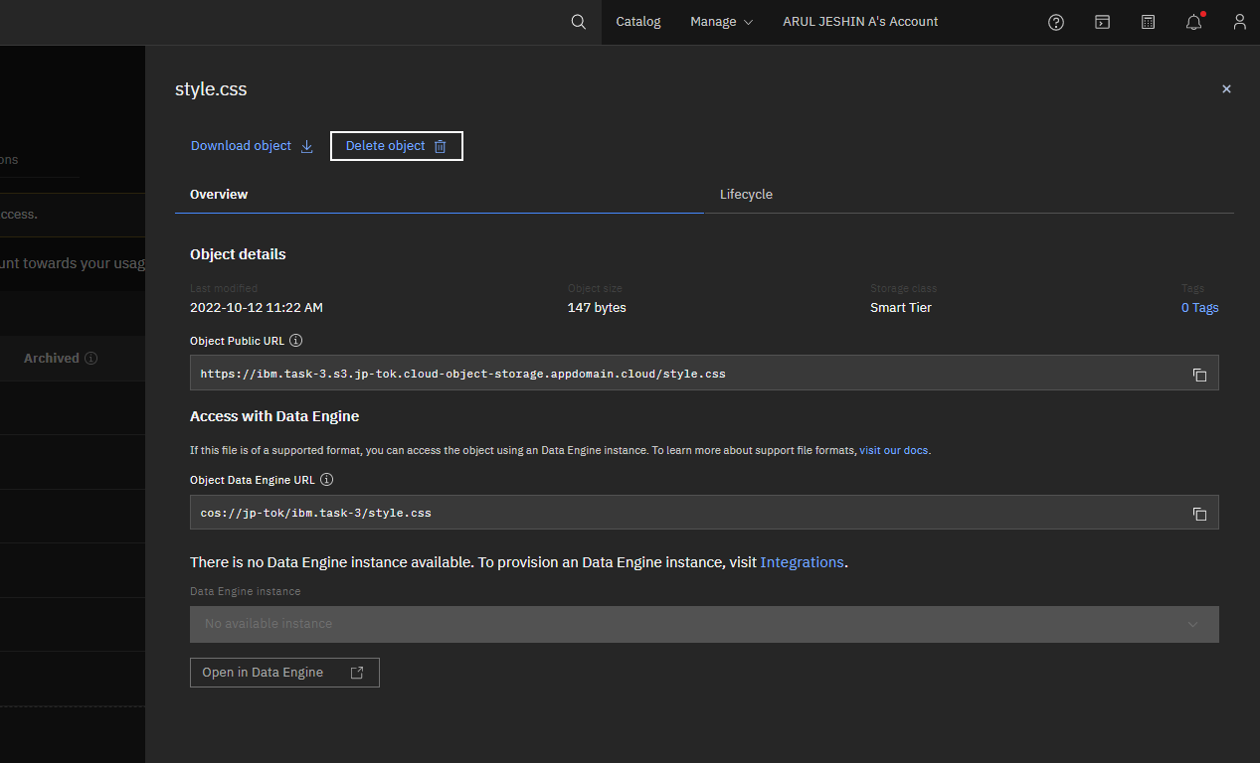

**HTML code:**

<!DOCTYPE html>

<html lang="en">

<head>

    <meta charset="UTF-8">

    <meta http-equiv="X-UA-Compatible" content="IE=edge">

    <meta name="viewport" content="width=device-width, initial-scale=1.0">

    <link rel="stylesheet" href="https://ibm.task-3.s3.jp-tok.cloud-object-storage.appdomain.cloud/style.css">

    <title>Simple</title>

</head>

<body>

    <h1>NARUTO</h1>

    <p>Naruto Uzumaki (うずまきナルト, Uzumaki Naruto) is a shinobi of Konohagakure's

        Uzumaki clan. He became the jinchūriki of the Nine-Tails on the day of his birth — a

        fate that caused him to be shunned by most of Konoha throughout his childhood. After

        joining Team Kakashi, Naruto worked hard to gain the village's acknowledgement all

        the while chasing his dream to become Hokage. In the following years, through many

        hardships and ordeals, he became a capable ninja, regarded as a hero both by the villagers,

         and soon after, the rest of the world, becoming known as the Hero of the Hidden Leaf. </p>

</body>

</html>

**HTML code output:**

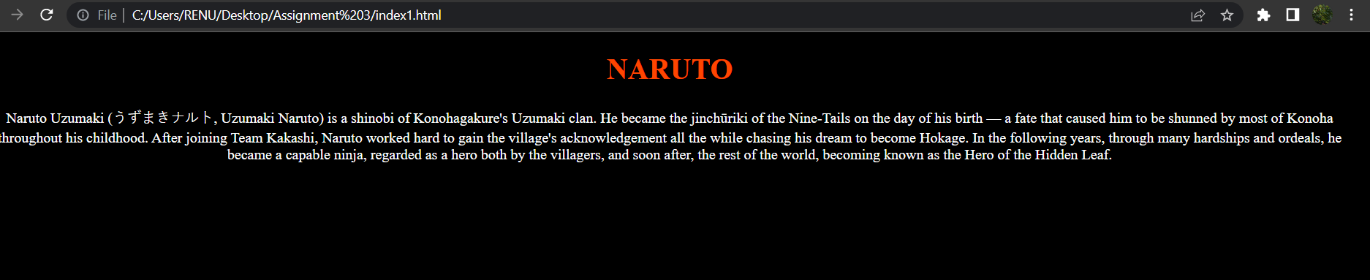

**Question 4:**

Design a chatbot using IBM Watson assistant for hospitals. Ex: User comes with a query to know the branches for that hospital in your city. Submit the web URL of that chat bot as an assignment.

**URL for the Chat Bot :**

https://web-chat.global.assistant.watson.appdomain.cloud/preview.html?backgroundImageURL=https%3A%2F%2Fjp-tok.assistant.watson.cloud.ibm.com%2Fpublic%2Fimages%2Fupx-a87d6922-53f6-49ac-9e54-24769839b6ba%3A%3A3aa22ca3-5cf8-4a9a-979b-69138399a023&integrationID=5c9a2bd5-1e5a-421c-bb44-b341d28835b6&region=jp-tok&serviceInstanceID=a87d6922-53f6-49ac-9e54-24769839b6ba

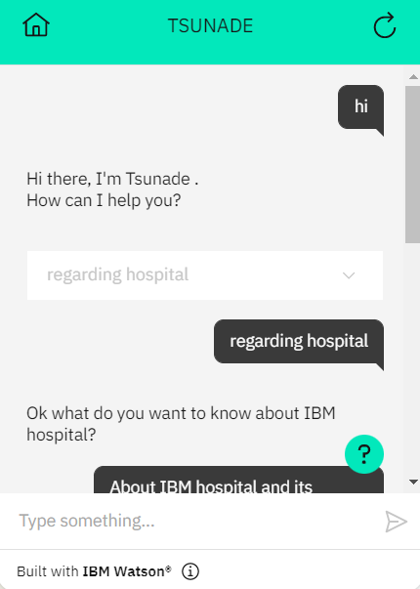

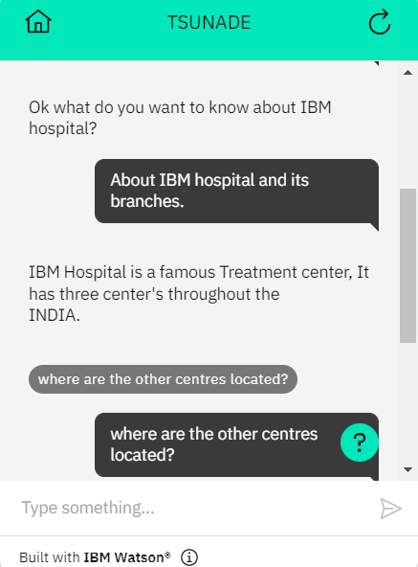

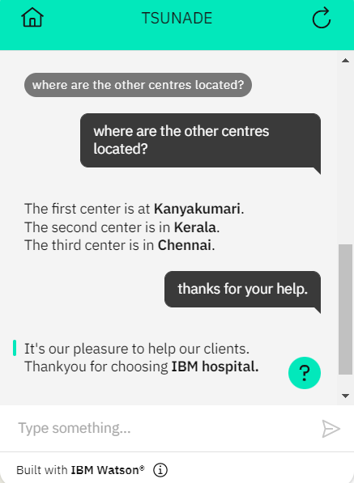

**Question 5:**

Create a Watson assistant service with 10 steps and use 3 conditions in it. Load that script in the HTML page.

**HTML CODE:**

<!DOCTYPE html>

<html lang="en">

<head>

<meta charset="UTF-8">

<meta http-equiv="X-UA-Compatible" content="IE=edge">

<meta name="viewport" content="width=device-width, initial-scale=1.0">

<title>Chat bot</title>

<style>

h1{

text-align: center;

color: #ffffff;

}

body{

background-color: #000000;

}

input[type="text"],input[type="password"]{

height: 42px;

width: 400px;

font-family: cursive;

border-radius: 100px;

background-color:rgb(15, 237, 174) ;

}

input[type="submit"]{

height: 42px;

width: 100px;

color: #000;

background-color: rgb(236, 232, 14);

font-size: medium ;

margin-top: 20px;

border-radius: 50px;

}

p{

color: #ffffff;

font-size: 28px;

}

form{

text-align: center;

}

small{

color: #ffffff;

}

img{

fill: auto;

}

</style>

</head>

<body>

<h1>Jeshin Welcomes you!!!</h1>

<h1>login to your account</h1>

<form>

<p>Enter-Username </p>

<input type="text" >

<br><br>

<p>Enter-Password </p>

<input type="password">

<br><br>

<input type="submit" value="login" >

<br><br>

<small>Click here to browse more <a href="https://www.youtube.com/watch?v=E40UEoa19As"> info</a></small>

</form>

<script>

  window.watsonAssistantChatOptions = {

    integrationID: "3c7e7559-008d-415e-9bee-db9d1950d6ea", // The ID of this integration.

    region: "jp-tok", // The region your integration is hosted in.

    serviceInstanceID: "a87d6922-53f6-49ac-9e54-24769839b6ba", // The ID of your service instance.

    onLoad: function(instance) { instance.render(); }

  };

  setTimeout(function(){

    const t=document.createElement('script');

    t.src="https://web-chat.global.assistant.watson.appdomain.cloud/versions/" + (window.watsonAssistantChatOptions.clientVersion || 'latest') + "/WatsonAssistantChatEntry.js";

    document.head.appendChild(t);

  });

</script>

</body>

</html>

**App.py code:**

from flask import Flask, render_template

app = Flask(__name__)

@app.route("/")

def home():

    return render_template("index2.html")

@app.route("/salvador")

def salvador():

    return "Hello, Salvador"

if __name__ == "__main__":

    app.run(debug=True)

**HTML CODE OUTPUT:**

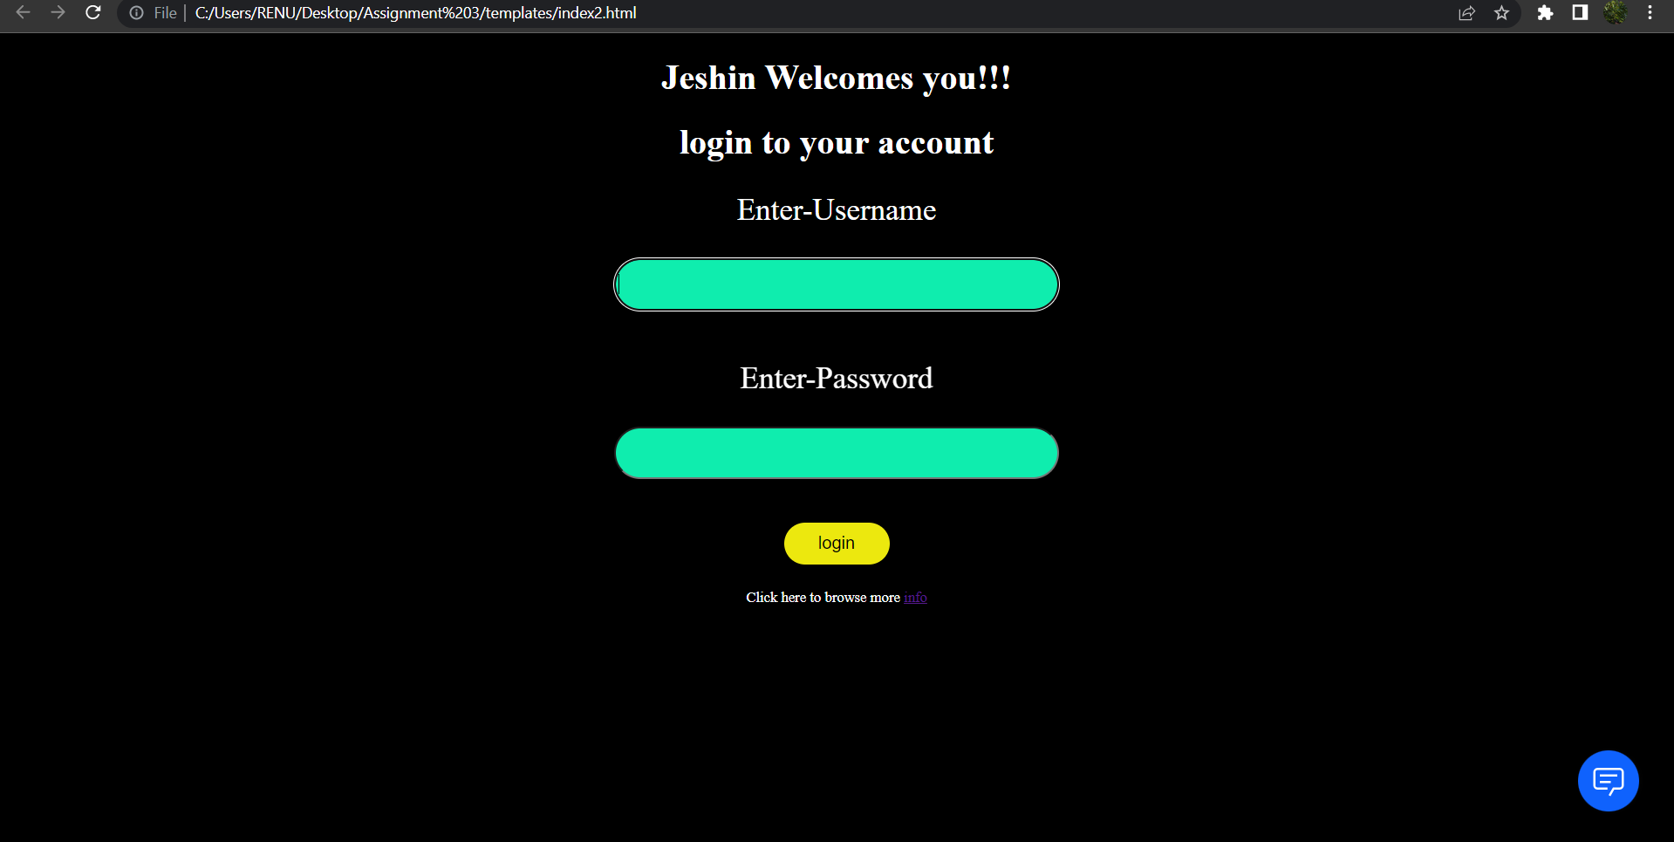

**ASSISTANT OUTPUT:**



